**Luxendo Photomanipulation Guide**

**Table of Contents**

TruLive3D-specific interlock procedure ……………………………………………………………………………… 2

MuVi SPIM-specific interlock procedure …………………………………………………………………………………

Calibration procedure ………………………………………………………………………………………………………

Experimental design ………………………………………………………………………………………………………..

**TruLive3D-specific interlock procedure**

1) Turn on the power strip and fill an Ibidi chamber with water + highlighter (**Fig 1**) or with phenol red media. Place chamber in TL3D and move into the objective FOV.

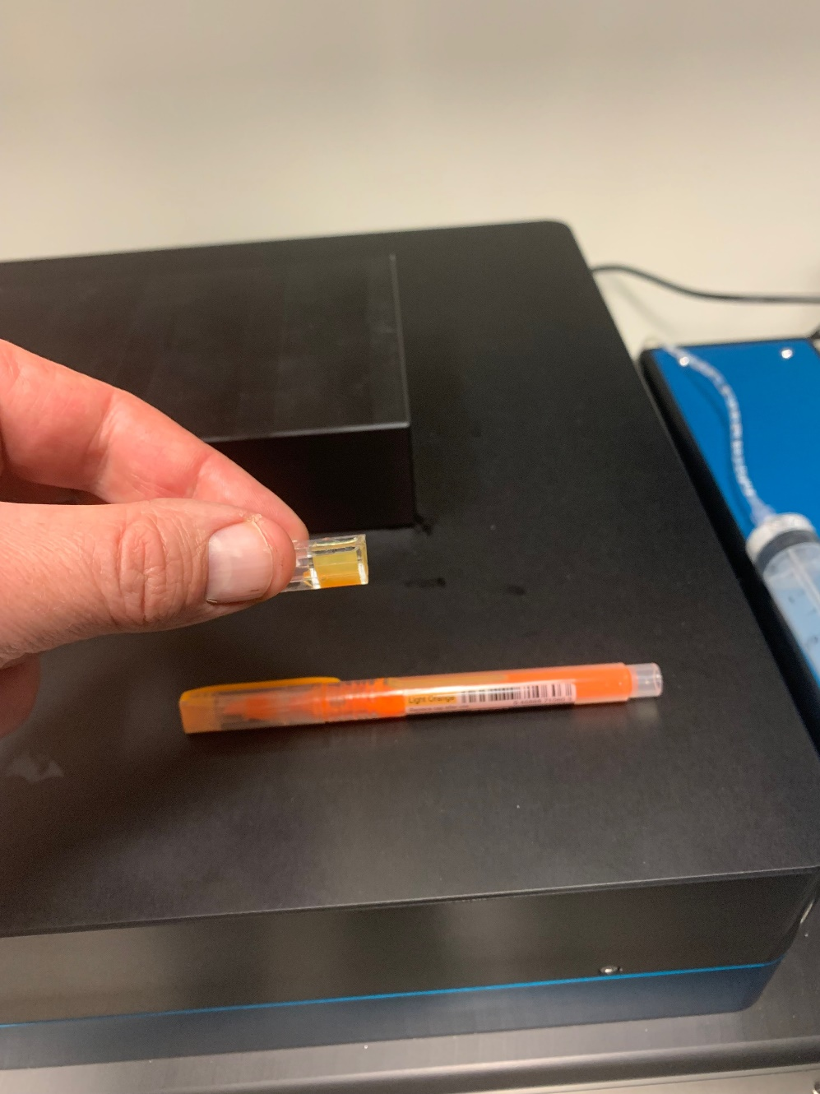

**Figure 1.** Orange highlighter as a fluorescent dye.

2) Depress interlock relay switch next to the heated lid (**Fig 2.**)

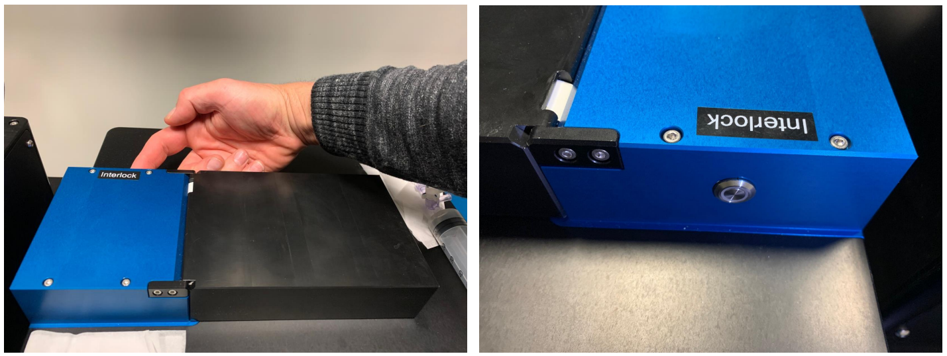

**Figure 2.** Interlock relay switch is located on the back side of the chamber lid.

Proceed to general calibration procedure (page 4)

**MuVi SPIM-specific interlock procedure**

1) Turn on the power strip. Place the photomanipulation cover on top of the chamber. The cable must be connected both to the cover and to the back of the microscope.

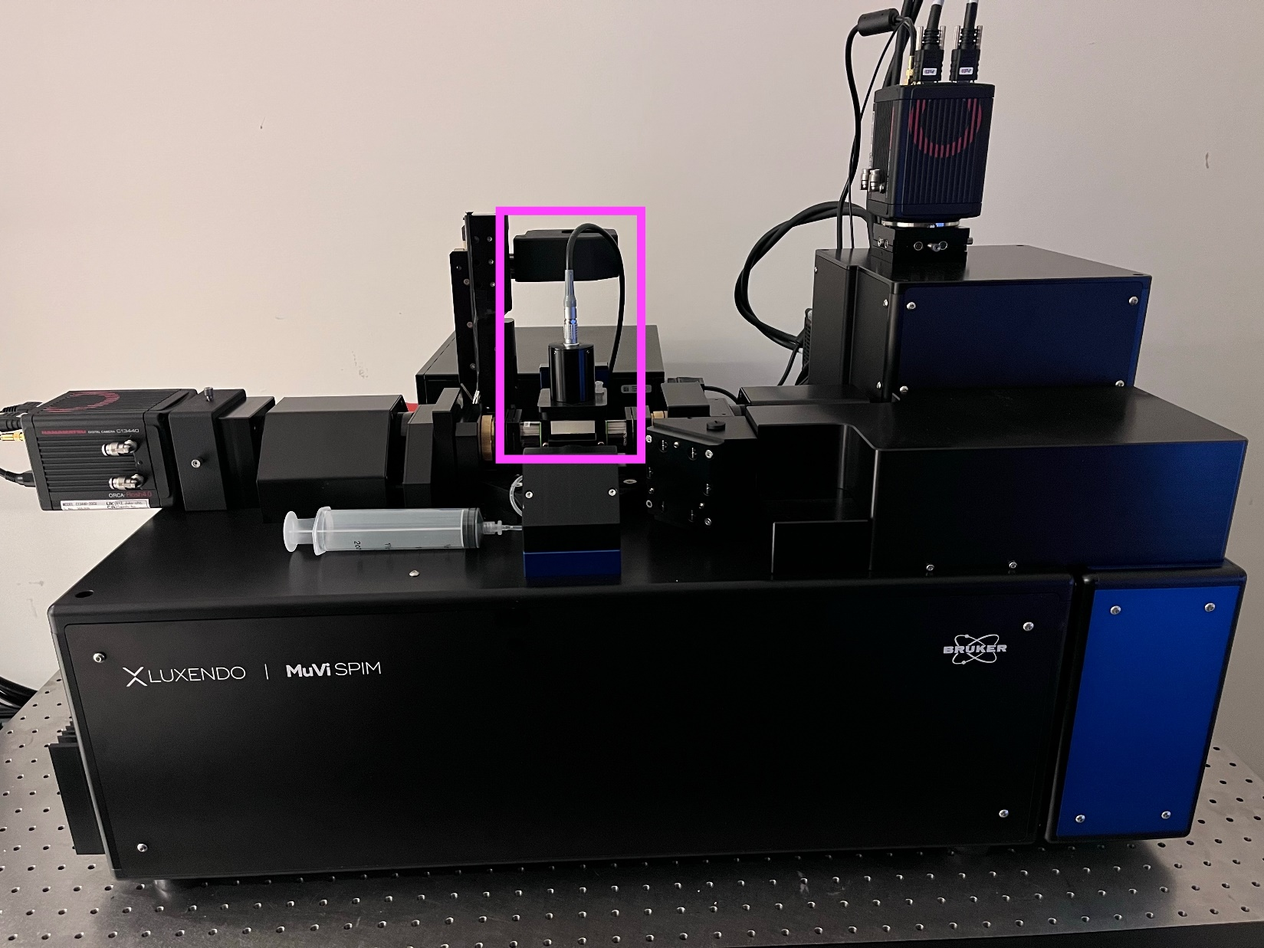

2) Press the interlock relay button on the back of the microscope.

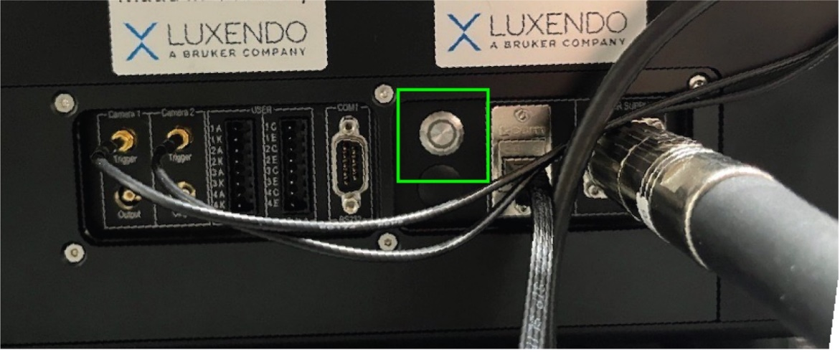

**Calibration procedure**

3) Launch the CryLas software. Select the correct Com port (will be system dependent) and click connect.

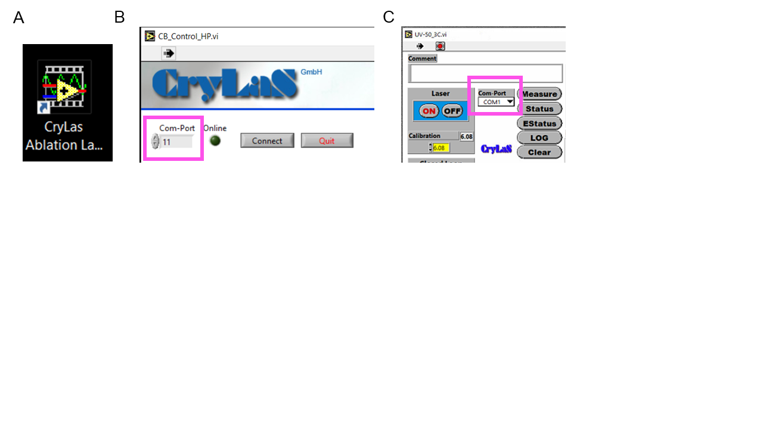

**Figure 3. Starting Crylas software.** Desktop shortcut for Crylas software (A). Com port input in newer software highlighted in magenta (B). Com port input in older software highlighted in magenta (C).

4) Set the appropriate laser value, repetition rate and turn the laser on (Fig 4). The laser power output and the case temperature over time are plotted in two line graphs below.

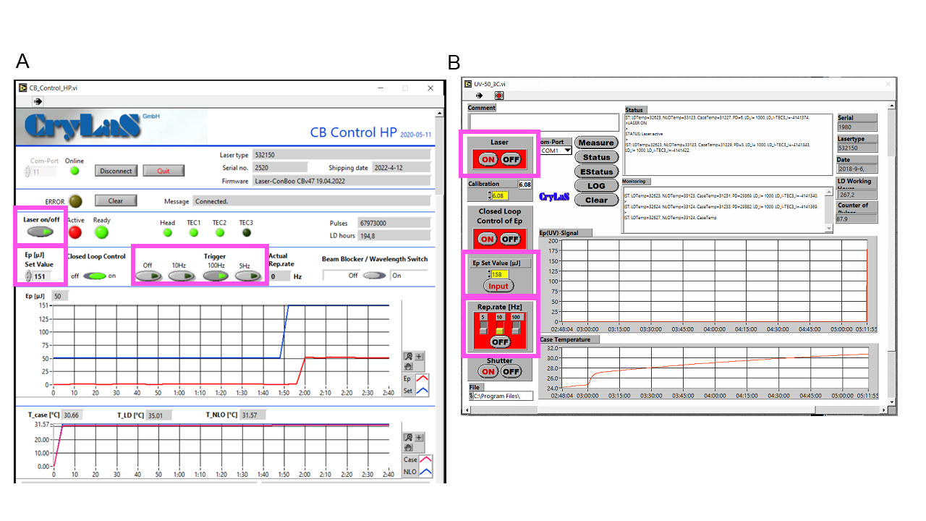

**Figure 4. Crylas control software.** Laser on/off switch, power output, and repetition rate control are highlighted in magenta for newer (A) and older Crylas software (B).

5) Open Lux Control and Navigate to the calibration tab. In Photomanipulation Calibration tab, enable the Photomanipulation.

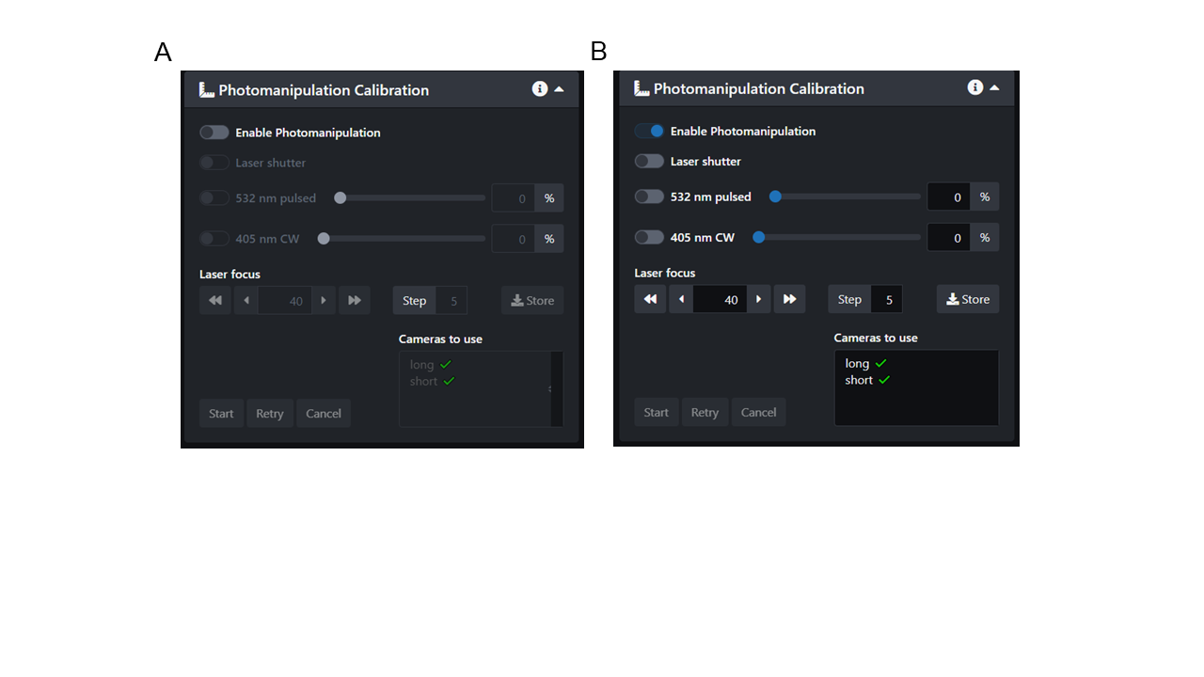

**Figure 5. Photomanipulation enable switch.** Photomanipulation is disabled (A) and enabled (B).

6) TL3D specific : In the detection pathway, Select the appropriate PM dichroic. For the TL3D the default position for imaging is an “empty” position for the ablation dichroic. For MuVi SPIM systems, there is only one dichroic and enabling the PM inserts this dichroic.

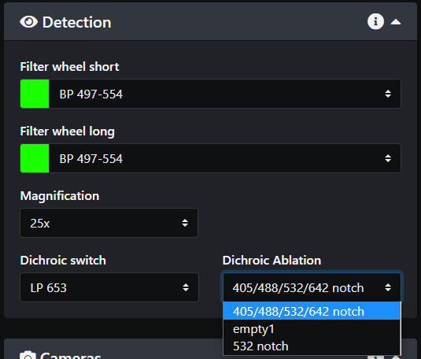

**Figure 6. Multi-position dichroic switch on the TruLive3D.** Under the Dichroic Ablation drop-down menu, users can select the dichroic of choice.

7) In the Photomanipulation Calibration tab, open the laser shutter and activate the PM laser. You will have intensity control of the laser intensity via an AOM. The upper limit of this intensity is set in the Crylas software.

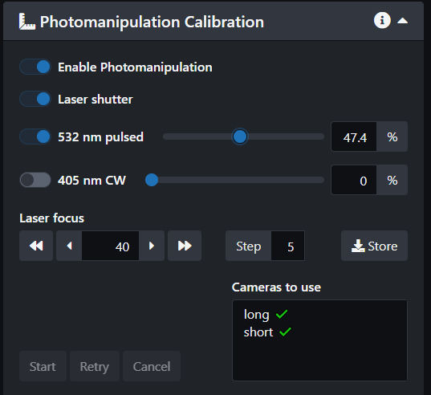

**Figure 7. Shutter and intensity modulation in Luxendo software.** Two radio buttons below “Enable Photomanipulation” give control for the laser shutter and analog power modulation.

8) Change the magnification of the microscope to the desired magnification for photomanipulation and adjust camera exposure time, filter position and PM laser intensity such that a laser spot can be seen on the desired camera for photomanipulation.

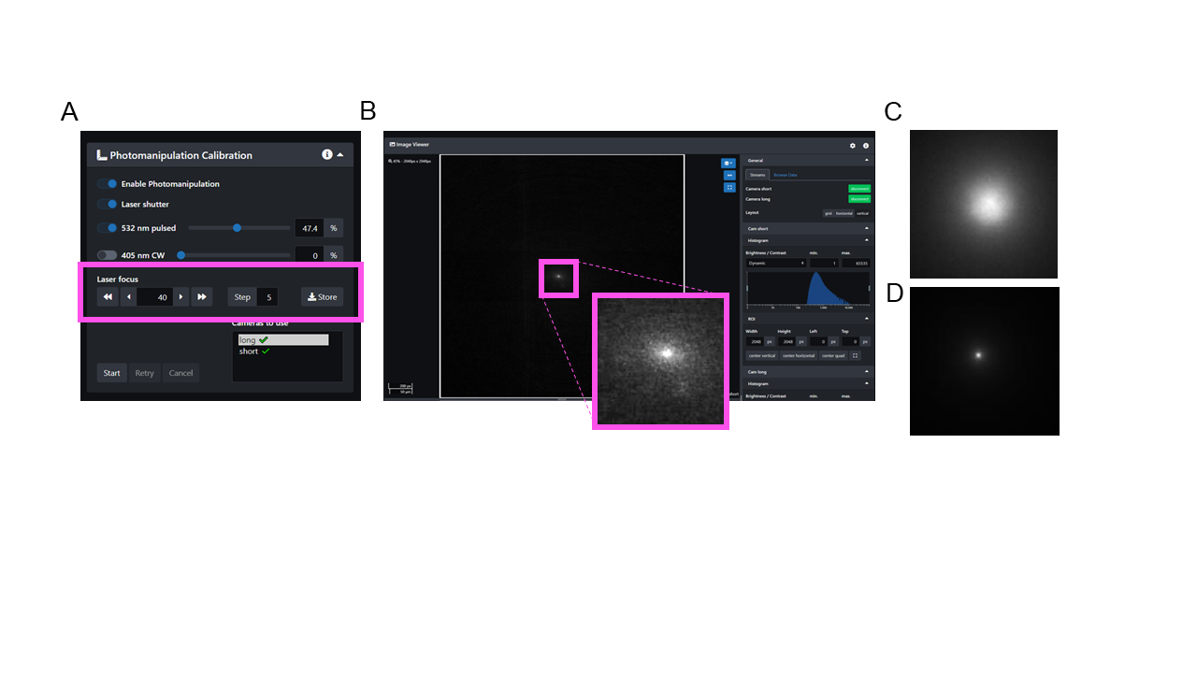

**Figure 8. Focusing the PM laser spot.** Laser focus is controlled in the PM calibration tab (A). Look for a small bright spot on the camera and minimize its size with focus control (B). Magenta inset shows laser spot. Defocused laser (C) and focused laser spot (D).

9) Highlight the camera(s) to calibrate. Note a beam must be visible on each desired camera in order to perform the calibration. Click “Start” to begin.

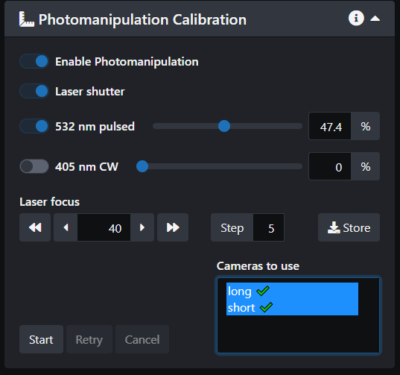

**Figure 9. Selecting cameras to calibrate.** Insets show the camera selection window and the Start button to initialize calibration.

10) A circle will appear around where the detected position of the beam is. If the detection fails, click retry. If it fails repeatedly adjust camera settings. Be sure all 5 point are correctly detected and click Finish to store the calibration.

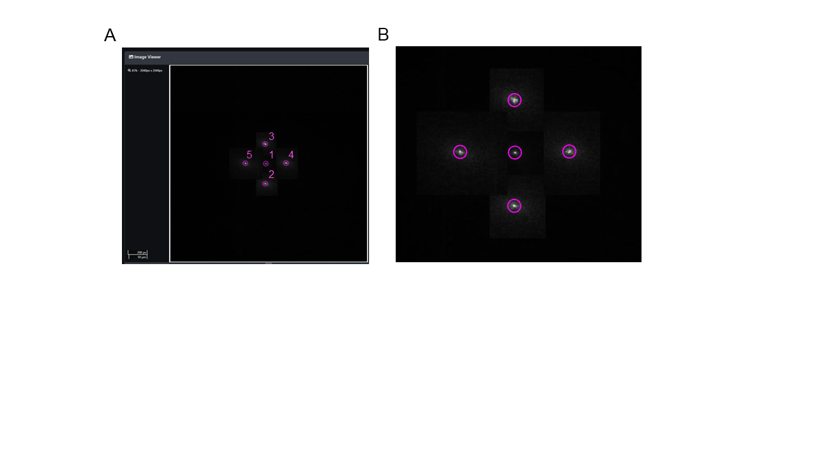

**Figure 10. Laser spot detection.** The laser is steered to five different points in the following order (A). Ensure that the laser is centered in the magenta detection ring (B).

11) Return to the dashboard, draw an ROI and test out the calibration. Direct mode will fire upon the release of the mouse click (single point) or the by doubling clicking to complete the line (line ROI). Standard mode will fire when “fire” is depressed.

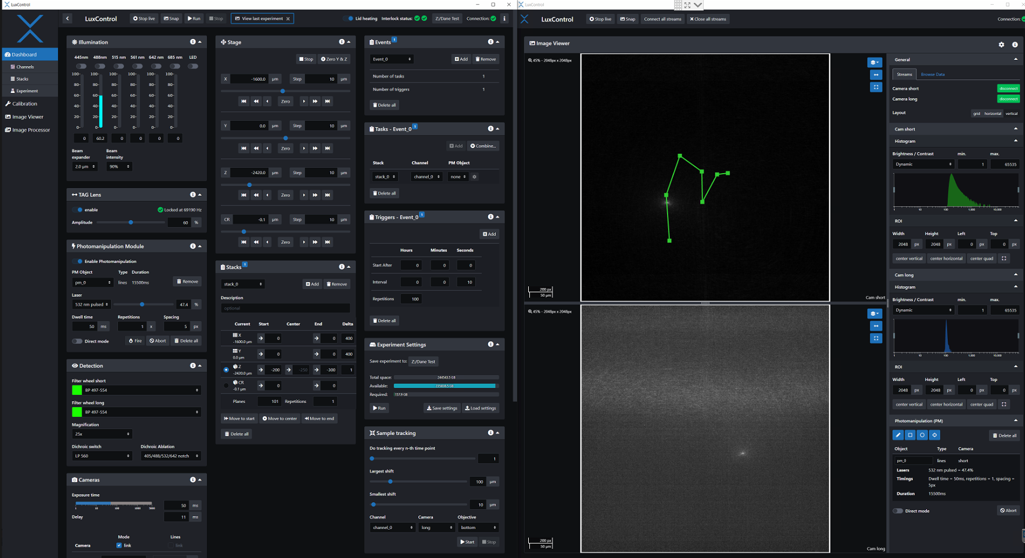

**Figure 11. Photomanipulation ROI creation.** In the bottom right corner, you may create lines and polygons. Lines will be traced while shapes are filled.

12) If you break the PM interlock, you will have to turn the Crylas laser back on in the Crylas software. Note if the red “laser active” light is not on, and the red power line is at 0, turn the laser off and on again.

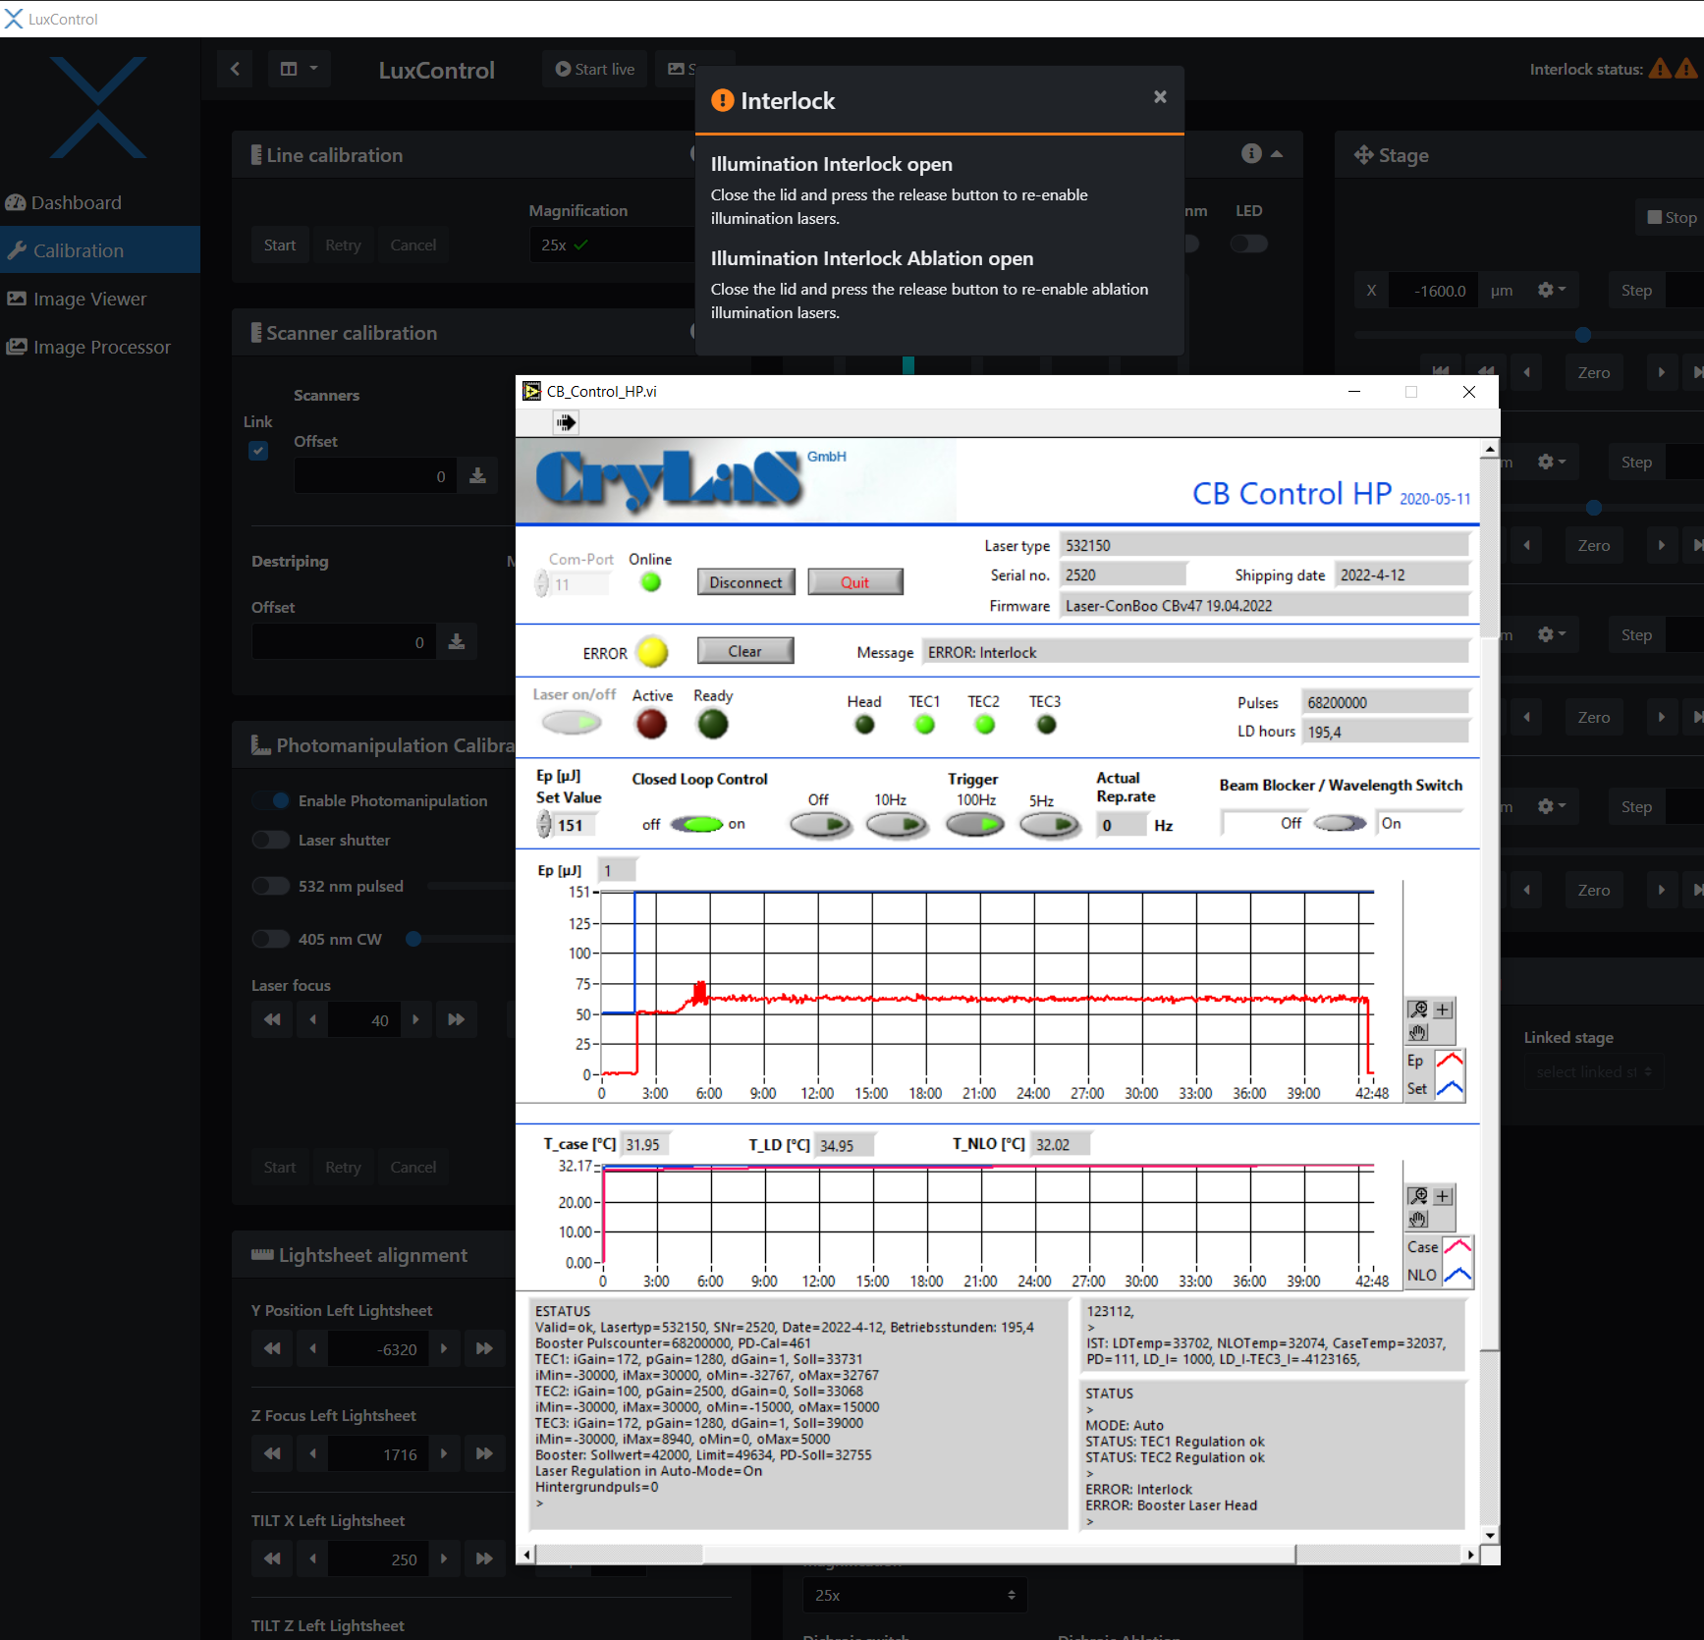

Notes: Shutter is specific to 532 laser, visible lines are directly modulated through Lux Control

**405 laser calibration**

1. Same calibration as above
2. Use laser focus adjustment to focus/defocus beam
3. Don’t forget to hit store. For 532 + Vis systems, Vis laser focus is the ~ the same as the 532 focus (which is hard to adjust by eye)

You see the bounds inside the dashed line are the possible steering locations for the PM

Youll also see the PM windows come up

Draw an object – lines follow and shapes fill. Single spit is the cross hair

For each object you have dwell time, repetitions and spacing.

To add the PM event into an experiment first well have 5 repetitions of pre-intervention imaging

Then a section event with the PM

Then a third event for post PM imaging

Create a stack with the plane of PM interest as the center

When configuring the PM event, the default is to do all planes. Check the start and end and hit confirm

Event 0 zero delay

Event 1 add in the delay “start after 30 secs”

Event 2 add in the delay “start after 1 min”

Make sure your interlocks are closed

If you break the interlock you will also have to turn the 532 back on in crylas software

For notre dame:

1. turn on the power strip

2. check to see the chiller is on ( its on the left, labeled laser, set to 25C)

3. open crylas control

4. in the save as, select a place to save the log file. Not important where

5. image 1 – defaults to com1

6. image 2 - change to com5 and check the connection

7. place the interlock cover on the chamber and press the relay button to close the interlock

8. image 3 – now you can turn on the laser on

9. press on for laser, press on for closed loop control, press 100hz rep.rate

10. optional, use the arrow keys and press input to change the laser power

11. image 4 – you can see the plot of laser power ramping up

12. image 5 - open Luxendo software and navigate to calibration. Make sure cameras are in area mode

13. image 6 – press enable photomanipulation, press the shutter, turn on the laser, and press start live

14. image 7 - adjust the laser power until you see a spot

15. focus and defocused images - use the laser focus to minimize spot size on the right camera and press store

16. image 8 – select the right camera and press start in the calibration

17 – image 9 – check to see the purple ring of best fit captures the spot

18- press next until all five steps are done

19 – once calibrated the bound will be blue dashed lines

20 – image 11 - draw a PM object and note the settings

21 now well setup your experiment. Three events: 0 for pre PM imageing 1: PM event 2: post PM imaging

22. image 12 – two channels to image once before PM

23. image 13 – event 1 has the pm event in the tasks. You need to update the “start after” to accommodate the time to image the first event. Here I start 1 min 30 secs after event 0

24. image 14 – press the gear to open the PM settings. For this stack with 226 planes I will choose plane 113 to be the manipulation plane.

25. image 15 – and 16alternatively create a different stack than your imaging plane, and select that stack

16. image 17 – event 2 starts 2:30 after to allow time for the first imaging stack and the PM event. This will now be our post PM imaging

17. press run

18. to turn off the laser and press the abort operation red button so that you can close the software

19. image 19 – now you can close crylas control and power down the strip